**END OF YRAR ASSESSMENT 2023**

**S.3PHYSICS (Competence Based Curriculum)**

**Time: 2 hours:**

**NAME: ……………………………………………………………………………………………………………………………………….**

**Attempt all questions in section A and two from section B**

**1 (a) Distinguish between potential energy and kinetic energy. (02 scores )**

**………………………………………………………………………………………………………………………………………………………………………………………………………………………………............................................................................................................................................................................................................................................................................**

**(b) Two forces of 5N and 12N acts at right angles on a block. Find the resultant force on the block. (03 scores)**

**………………………………………………………………………………………………………………………………………………………………………………………………………………………………...................................................................................………………………………………………………………………………………………………………………………………………………………………………………………………………………………...............................................................................................................................................................**

**2(a) State the principle of moments (02 scores)**

**………………………………………………………………………………………………………………………………………………………………………………………………………………………………...........................................................................................................................**

**(b) A Car of mass 90kg at a distance of 6m from side A of a bridge, moves along a uniform bridge of length 16.0m and weight 20N. If the bridge was supported by two stands at its ends, Find the reactions at the supports. (05 scores)**

**………………………………………………………………………………………………………………………………………………………………………………………………………………………………...................................................................................……………………………………………………………………………………………………………………………………………………………………………………………………………………………….............................................................................................................................................................**

**(c) What are the 3 states of equilibrium? Use diagrams to illustrate them. (03 scores)**

**………………………………………………………………………………………………………………………………………………………………………………………………………………………………...................................................................................………………………………………………………………………………………………………………………………………………………………………………………………………………………………..................................................................................................................................................................................................................................................................................................................**

**3.Give 3 types of simple machines and their application in real life. (06 scores)**

**………………………………………………………………………………………………………………………………………………………………………………………………………………………………...................................................................................………………………………………………………………………………………………………………………………………………………………………………………………………………………………..................................................................................................................................................................................................................................................................................................................**

**(b) Why do you think machines are never 100% efficient? (02 scores)**

**………………………………………………………………………………………………………………………………………………………………………………………………………………………………...........................................................................................................................**

**(c) Draw a system of 3 pulleys and state the velocity ratio. (02 scores)**

**………………………………………………………………………………………………………………………………………………………………………………………………………………………………...................................................................................…………………………………………………………………………………………………………………………………………………………………………………………………………………………………………**

4)A student set up an experiment in the laboratory as shown below.

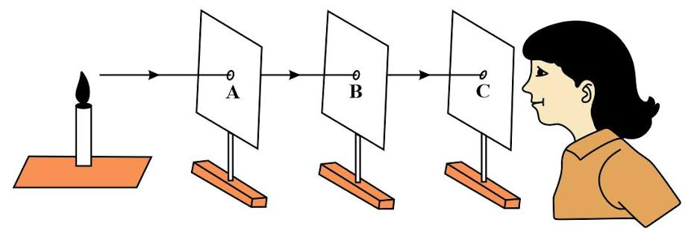

a) What principles was a student investigating. (1 score )

......................................................................................................................................................

..........…....….…...............................................................................................................................

b) Explain what is observed if one cardboard is slightly pushed off the line such that the holes are nolonger in the straight line. (1 score )

..................................………..……...….............…............…..........................…...................…................ ...................................………..……...….............…............…..........................…...................….............

c) What conclusion can you make from 3b above? (1score)

...................................………..……...….............…............…..........................…...................….............. ...................................………..……...….............…............…..........................…...................…..............

**5)**

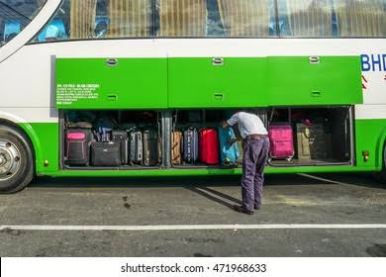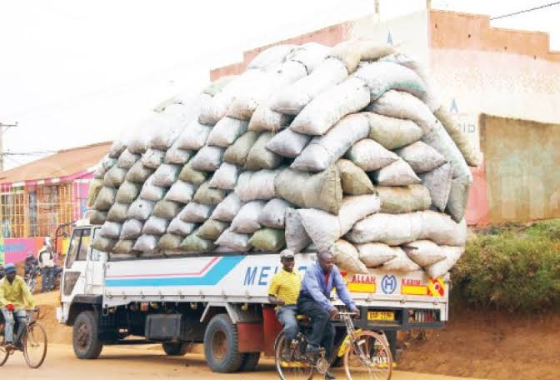

a) Explain why it is risky in relation to stability to load a truck as shown on the right hand side above. (3scores)

...................................................................................................................................................................................................................................................................................................................................................................................................................................................................

.........

.…....….…...............................................................................................................................

..........…....….…...............................................................................................................................

b) Why the current design of the buses allows loading luggage in bus cabins as shown on your left hand side above, than carrying it on the top of roof racks. (3scores)

.............................................................................................................................................................................................................................................................................................................

..........…....….…..............................................................................................................................

..........…....….…............................................................................................................................................

c) Identify 3 ways of increasing the stability of the body. (3scores)

.......................................................................................................................................................

..........…....….…......................................................................................................................................................................................................................................................................................

6. A head teacher instructed the school carpenter to make a notice board of dimensions 1.5 m by 0.5 m. If each notice is written on a piece of paper of dimensions 21 cm by 30 cm, what is the maximum number of notices that can be put on the notice board at any one time? (4 scores)

……………………………………………………………………………………………………………………………………………………………………………………………………………………………………………………………………………………………………………………………………………………………………………………………………………………………………………………………………………………………………………………………………………………………………………………………………....….…................................................................................................................................

**SECTION B ( choose two questions and must be answered on sheets)**

7a)In a certain TV show, a set of games in which the winner gets a good prize for the challenge(s) is aired , Joel a S.3 student at St.Andrew Kaggwa Gombe high school joins the competition and finds out that he was required to climb

**9 steps** each of height **15cm** to move a load of mass **25kg.** On reaching the top ,he discovered that he had to carry a load of **65kg** for a distance of **2m** upto the finish point for a duration of **5minutes**



**Task: a)** You are one of the judges on this show and your role is to compute the following

1. The work done as he climbs the steps upto the last one
2. Work done when he is carrying a load of **65kg** for the distance of **2m**
3. Power used when carrying the load for **5minutes (10scores)**

8) After winning a singing competition, Brenda decided to buy a piece of land from one of the property consultants in the her community to start her projects. she was shown two plots A and B of the **same price** but different measurements, **plot A** was measuring **45m by 100m** while **plot B** was measuring **70m by 80m.**

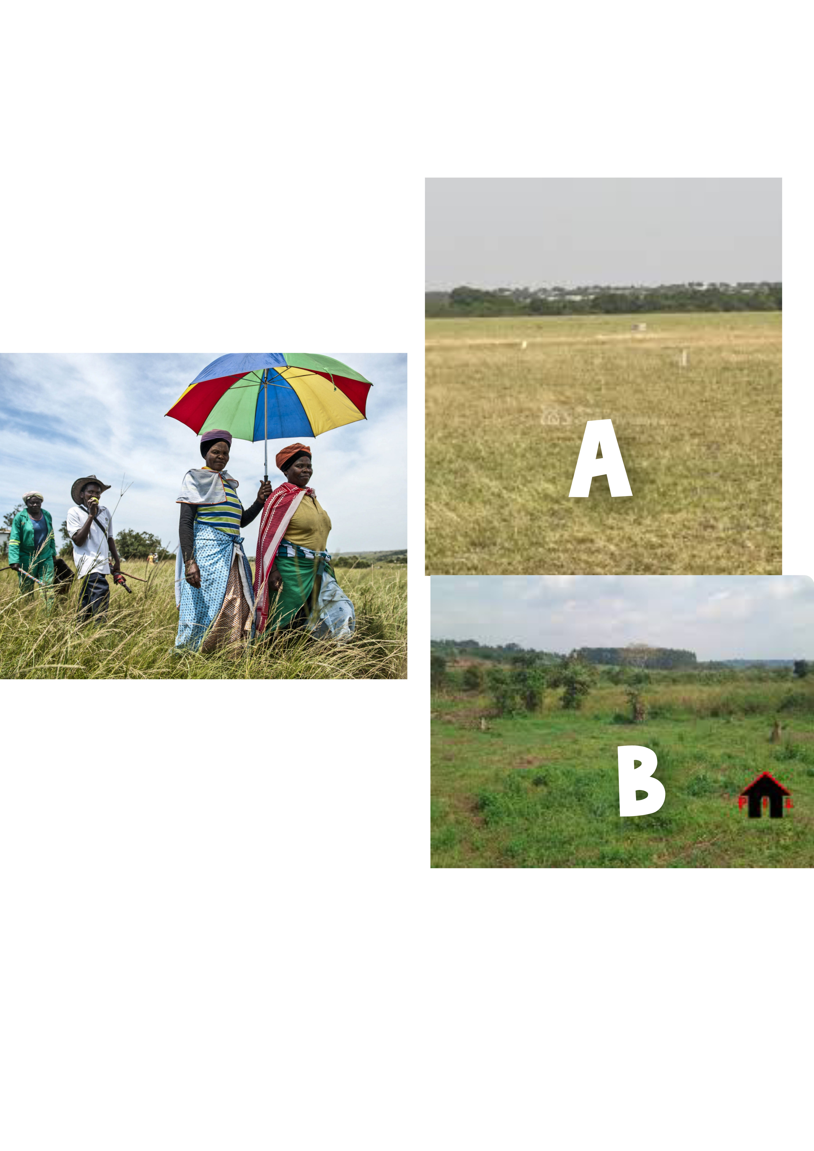

Task

a) With a reason which plot would you advise Brenda to buy(7scores)

b) The head teacher ordered the carpenter to make a notice board for the school, the noticed board measured 150cm by 100cm after being made. If the head teacher is to fully use the notice board by pinning documents measuring 30cm by 15cm. what is the maximum number of documents that can be pinned on the board on a given day (8Scores)

9) Sound is quite a useful form of energy in daily life

a)Identify any three properties of sound(3scores)

b)A certain radio station Broad casts at a frequency of 3×10⁶Hz determine the wavelengthof waves produced if the velocity is 3×10⁸ms-¹**(3 scores)**

**c)How can you use** (an electric bell inside a jar having one outlet leading to a source of electricity connected to the bell and the other outlet leading to a vacuum pump) **to demonstrate the effect of** **air on movement of sound** (5months)

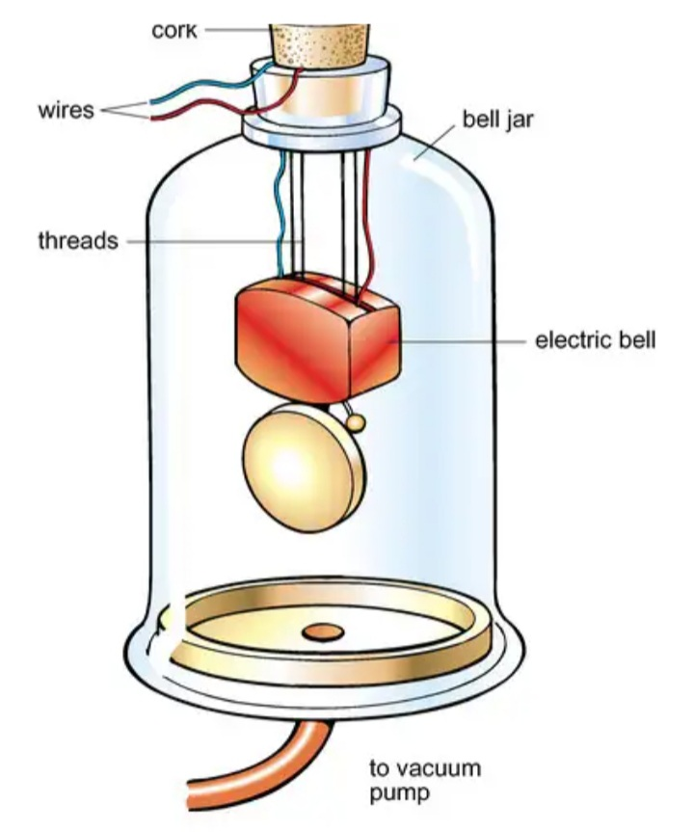

**(5**

d)A girl stands 640m from a wall and makes loud sound. After 4 seconds, she hears her sound repeated by the wall

1. Account for the sound from the wall **(1score)**
2. Establish how fast the sound was moving based on the measurements given **(3 scores)**

**END (Happy X-mas)**

0772752184